

Project Name: MEDCARE

Documentation On

**“MEDCARE”**

E-DAC Sept-2022

**Guided By: Bakul Joshi**

Submitted By:

**Group No: 06**

* **Prajwal Mowade 210943020067**
* **Saurabh Gunthe 210943020086**
* **Uday Kirange 210943020105**
* **Sumit Katore 210943020098**

**Table of Contents**

**1. Introduction 4**

1.1 Document Purpose **4**

1.2 Project Background **4**

1.3 Aim & Objectives **4**

**2. Business Requirements Overview**…………………………………………………………**5**

**3.Functional Requirements** **5**

3.1 Admin Module **5**

3.2 Hospital Module **6**

3.3 User Module **6**

3.3 Doctor Module **6**

**4.** **Non-Functional Requirement………………………………………………………………6**

**5. Use Case Diagram 7**

5.1 User **7**

5.2 Doctor **8**

5.3 Admin **9**

5.4 Hospital **10**

**6. Database Design 10**

1 Admin **10**

2 Hospital **10**

3 Doctor…………………………………………………………………………………… **10**

4 User **11**

5 Payment_details **11**

6 Blogs **11**

7 Appointment **11**

8 Consultation **11**

9 Login **11**

**7. E-R Diagram………………………………………………………………………………………12**

**8. Snapshots 13**

**9. Conclusion 25**

1. **Introduction:**
   1. **Document Purpose:**

This document communicates the business requirements and scope for developing MEDCARE System. The scope of this document is to define the functional and non-functional requirements, business rules and other constraints requirements.

## Project Background:

By considering current crises such as covid-19 multiple peoples faced multiple issues regarding their health. Some of the issues are financial problems, proper treatment, proper consultation with doctors and common precautions etc. There is no proper system currently present in healthcare sector that resolve all that issues. Currently, patients visit hospitals then only they get to know about diseases which sometimes becomes too late to recover. Currently, there is no healthcare system that follows “Prevention is better than Cure”.

## Aim & Objectives:

The main objective of this project is to create a healthcare system that resolve major problem faced by the patients for ex. financial problem,

Proper precautions, proper treatments etc.

Here if user want to take benefits of these, they have to create an account by purchasing an insurance policy and then by using our application they get an access to get appointment with best doctors in best hospitals, they get contact of doctors for virtual communication, they get consultation about medicine, and also, they get ideas about proper health care.

For doctors perspective they can get their daily schedule means their daily appointments with patients, get details about patients, they have full access to patient’s information for betterment in future, and also they can publish blogs about precautions frequently.

1. **Business Requirements Overview:**

* MEDCARE is a public web application.
* The MEDCARE system will be opened to the global, but at the start the main target is in one city.
* There are mainly two types of customers. User and Doctor
* User can purchase an insurance which helps user to face financial problems during treatments.
* User have access to read daily blogs.
* User can search for best doctors and hospitals to take an appointment with them.
* User gets contact of doctors and also consult about medicines.
* User gives ratings to hospital
* Doctors can get their daily appointments schedule.
* Doctors can access the information about patients.
* Doctors can publish daily blogs on proper health care.

# Functional Requirements Overview:

1. Admin Module
2. Hospital Module
3. User Module
4. Doctor Module

3.1 Admin Module

* Admin can create the hospitals.
* Admin can upload and update insurance policy.

3.2 Hospital Module

* Hospital can login
* Upload and update information about doctors, facilities, infrastructure etc

3.3 User Module

* User register using buying insurance
* User gets login.
* User browse information about hospitals and their facilities.
* User can take appointment with doctors.
* User can get consultation about medicines.
* User can read blogs.

3.4 Doctors Module

* Doctor gets login.
* Doctor can update profile.
* Doctor views daily appointments with patients.
* Doctor approve appointment for online consulting.
* Doctor give consultation to patients.
* Doctor can publish blogs.

# 4. Non-functional Requirements

* The Web Application should use professional design, look and feel and colour scheme.
* Users will have no limitations for accessing the Web Application through Internet. The portal being an internet application.
* The system should have user friendly interface. It should be easily updated, modified and reused.
* The system should be available 24/7.
* Being a public Web Application, the application must follow general usability guidelines for menus, buttons, links and other actions provided on the screens.
* The Web Application should be designed in such a manner that user will be able to navigate easily.

## 5. Use-Case Diagram

**5.1 User:**

Fig : Use case diagram for user

In use case diagram of user. User is a actor.

User can handle following use cases:

1. Get Insurance
2. Login
3. Forgot Password
4. Get Appointment
5. Get Consultation
6. Logout
7. Read Blogs

## 5.2 Doctor:

Fig : Use case diagram for doctor

In use case diagram of doctor. Doctor is a actor.

Doctor can handle following use cases:

1. Login
2. Forgot Password
3. Get appointment schedule
4. Approve Appointment
5. Give Consultation
6. Publish Blogs
7. Logout

**5.3 Admin:**

Fig : Use case diagram for admin

In use case diagram of admin. Admin is a actor.

Admin can handle following use cases:

1. Login
2. Register Hospital
3. Upload and Update Insurance
4. Logout

**5.4 Hospital:**

Fig : Use case diagram for hospital

In use case diagram of hospital. Hospital is a actor.

Hospital can handle following use cases:

1. Login
2. Forgot Password
3. Add Doctors
4. Add Departments
5. Logout

**6. Database Design:**

**Admin:**

|  |  |  |  |  |  |
| --- | --- | --- | --- | --- | --- |
| **Field** | **Type** | **Null** | **Key** | **Default** | **Description** |
| Aid | Integer | No | Primary key |  | Admin ID |
| Name | Varchar(45) | No |  |  | Admin Name |
| Email | Varchar(45) | No |  |  | Email ID Of Admin |
| Contact | Varchar(15) | No |  |  | Contact of admin |
| Address | Varchar(45) | No |  |  | Address of admin |
| Lid | Integer | No | Foreign Key |  | References to Login(Lid) |

**Hospital:**

|  |  |  |  |  |  |
| --- | --- | --- | --- | --- | --- |
| **Field** | **Type** | **Null** | **Key** | **Default** | **Description** |
| Hid | Integer | No | Primary key |  | Hospital ID |
| Name | Varchar(45) | No |  |  | Hospital Name |
| address | Varchar(45) | No |  |  | Hospital Address |
| Specialization | Varchar(15) | No |  |  | Hospital Specialization |
| Rating | Integer | No |  |  | Hospital Rating |
| Lid | Integer | No | Foreign Key |  | References to Login(Lid) |

**Doctor:**

|  |  |  |  |  |  |
| --- | --- | --- | --- | --- | --- |
| **Field** | **Type** | **Null** | **Key** | **Default** | **Description** |
| Did | Integer | No | Primary key |  | Doctor ID |
| Name | Varchar(45) | No |  |  | Doctor Name |
| Dob | Varchar(45) | No |  |  | Date of birth of doctor |
| Address | Varchar(15) | No |  |  | Doctor Address |
| Email | Varchar(45) | No |  |  | Email of doctor |
| Mobial | Varchar(100) | No |  |  | Mobial no of doctor |
| Gender | Varchar(10) | No |  |  | Gender Information |
| Specialization | Varchar(45) | No |  |  | Doctor specialization |
| Education | Varchar(45) | No |  |  | Education details |
| Experience | Varchar(45) | No |  |  | Experience details |
| Hid | Integer | No | Foreign key |  | references to Hospital(Hid) |
| Lid | Integer | No | Foreign Key |  | References to Login(Lid) |

**User:**

|  |  |  |  |  |  |
| --- | --- | --- | --- | --- | --- |
| **Field** | **Type** | **Null** | **Key** | **Default** | **Description** |
| Uid | Integer | No | Primary key |  | User ID |
| Name | Varchar(45) | No |  |  | User Name |
| Address | Varchar(45) | No |  |  | Address of user |
| Mobial | Varchar(45) | No |  |  | Mobial no of user |
| Email | Varchar(15) | No |  |  | Email of User |
| AadharNo | Varchar(15) | No |  |  | Aadhar No. Of User |
| Dob | Varchar(100) | No |  |  | Date of birth |
| Gender | Varchar(10) | No |  |  | Gender Information |
| Date | Varchar(15) | No |  |  | Date of buying insurance |
| Lid | Integer | No | Foreign Key |  | References to Login(Lid) |

**Payment_Detail:**

|  |  |  |  |  |  |
| --- | --- | --- | --- | --- | --- |
| **Field** | **Type** | **Null** | **Key** | **Default** | **Description** |
| Id | Integer | No | Foreign key |  | references to User(Uid) |
| AccountNo | Varchar(45) | No |  |  | Account Number |
| Name | Varchar(45) | No |  |  | Account Holder Name |
| Payment | Varchar(45) | No |  |  | Amount Paid |

**Blogs:**

|  |  |  |  |  |  |
| --- | --- | --- | --- | --- | --- |
| **Field** | **Type** | **Null** | **Key** | **Default** | **Description** |
| Bid | Integer | No | Primary Key |  | Blog Id |
| Did | Integer | No | Foreign key |  | references to Doctor(Did) |
| Content | Varchar(200) | No |  |  | Content of blog |
| Date | Varchar(45) | No |  |  | Date of publish blog |

**Appointment:**

|  |  |  |  |  |  |
| --- | --- | --- | --- | --- | --- |
| **Field** | **Type** | **Null** | **Key** | **Default** | **Description** |
| Aid | Integer | No | Primary key |  | Doctor ID |
| Uid | Integer | No | Foreign key |  | references to User(Uid) |
| Did | Integer | No | Foreign key |  | references to Doctor(Did) |
| Date | Varchar(20) | No |  |  | Appointment date |
| Time | Varchar(20) | No |  |  | Appointment Time |
| Status | Varchar(45) | No |  |  | Appointment status |

**Consultation:**

|  |  |  |  |  |  |
| --- | --- | --- | --- | --- | --- |
| **Field** | **Type** | **Null** | **Key** | **Default** | **Description** |
| Cid | Integer | No | Primary key |  | Consultation ID |
| Uid | Integer | No | Foreign key |  | references to User(Uid) |
| Symptoms | CLOB | No |  |  | Symptoms |
| Did | Integer | No | Foreign key |  | references to Doctor(Did) |
| Response | CLOB | No |  |  | Response given by doctor |
| Date | Varchar(20) | No |  |  | Appointment date |
| Time | Varchar(20) | No |  |  | Appointment Time |

**Login:**

|  |  |  |  |  |  |
| --- | --- | --- | --- | --- | --- |
| **Field** | **Type** | **Null** | **Key** | **Default** | **Description** |
| Lid | Integer | No | Primary key |  | Login Id |
| Role | Varchar(45) | No |  |  | Role of user |
| Username | Varchar(45) | No |  |  | Username |
| Password | Varchar(45) | No |  |  | Password |

## 7. ER-Diagram:

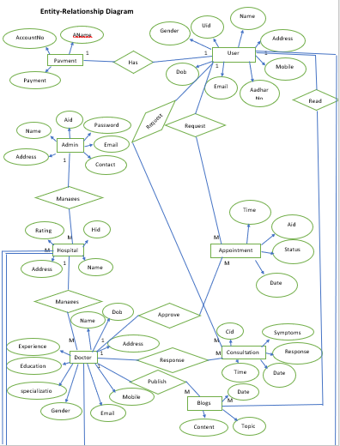

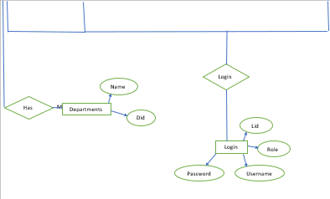

**E-R diagram shows database of Medcare**

**8. Snapshots:**

**8.1 Home Page:**

Following snapshot shows the Home page for Medcare

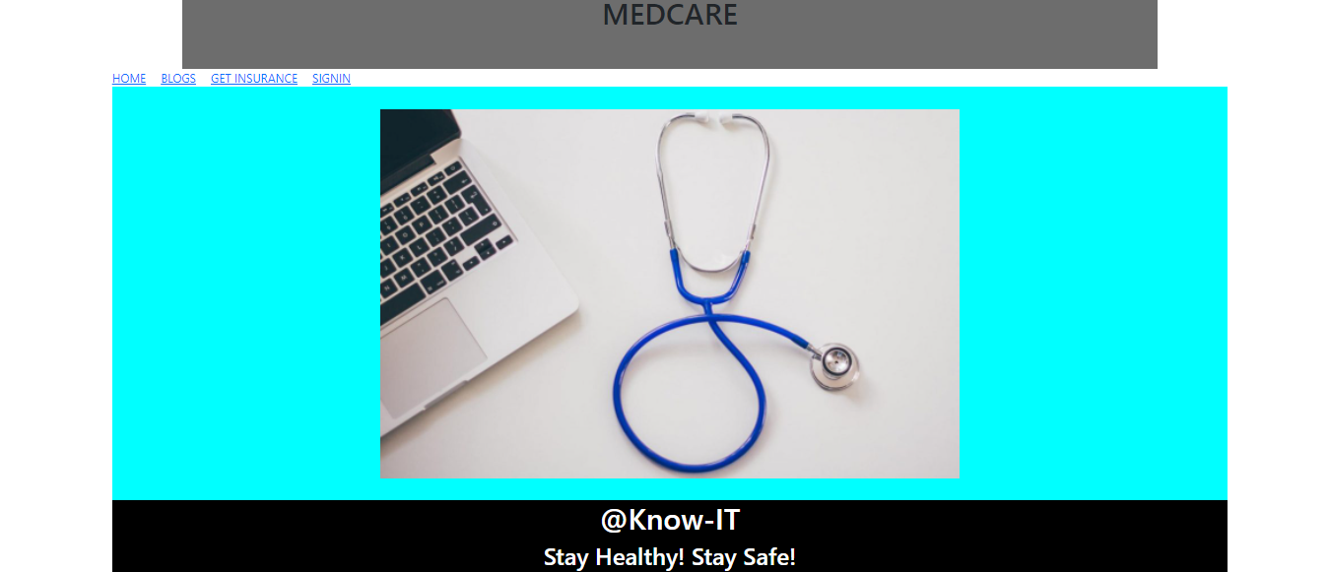

This page contains following controls

* Home
* Blogs
* Get Insurance
* Login

**8.2 Insurance Home**

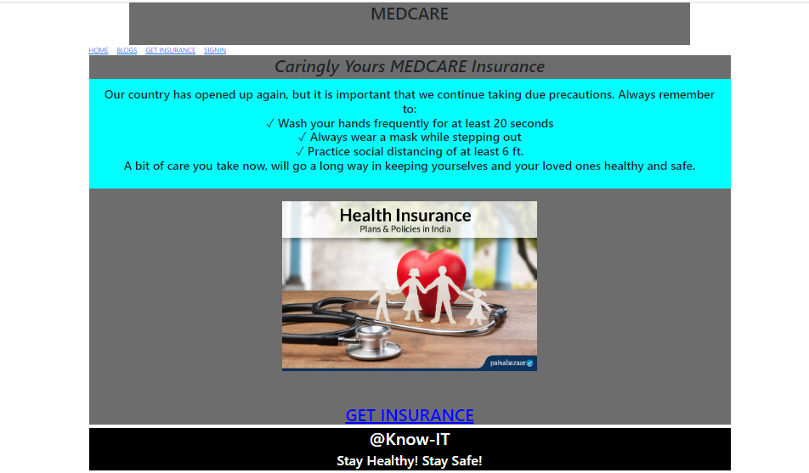

**8.2.1 Insurance Registration**

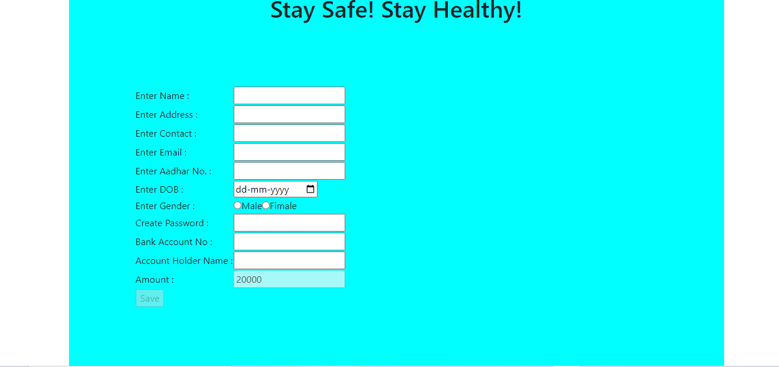

**8.3 Patient Home**



**8.3.1 Hospital Page**

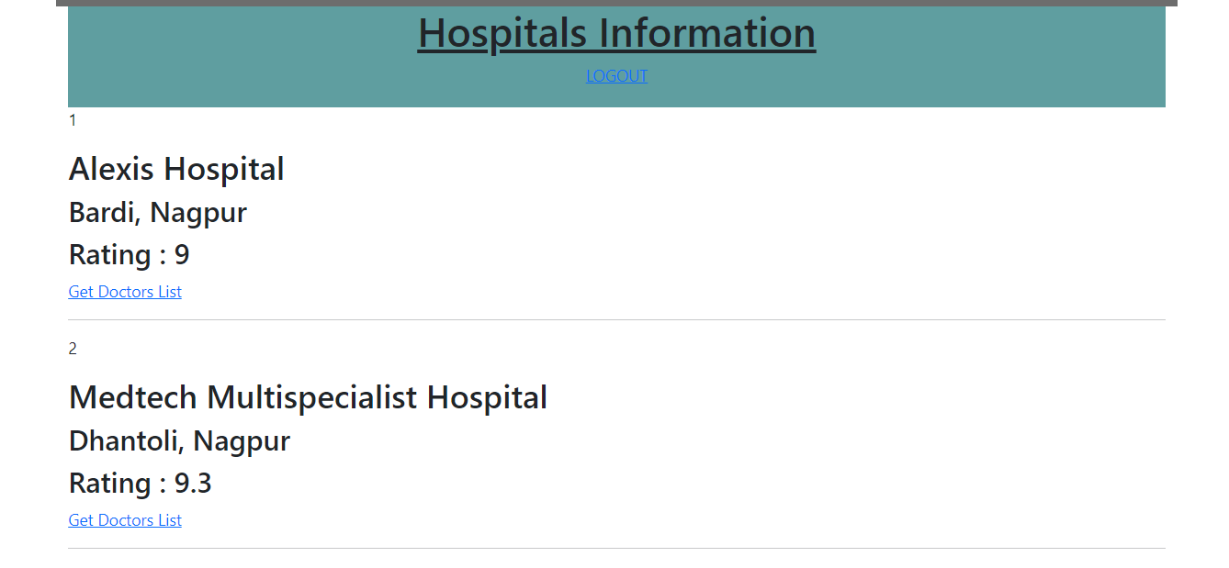

**8.3.1.1 Doctors page**

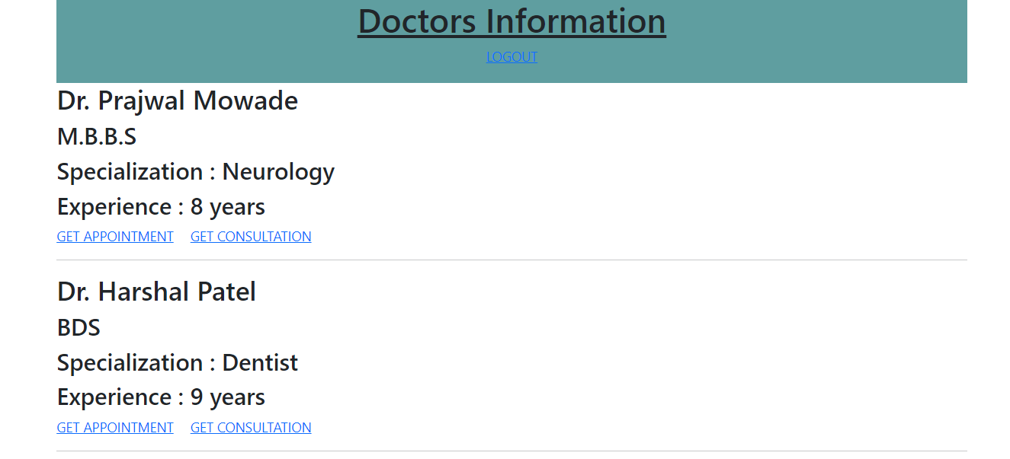

**8.3.1.1.1 Appointment Request Page**

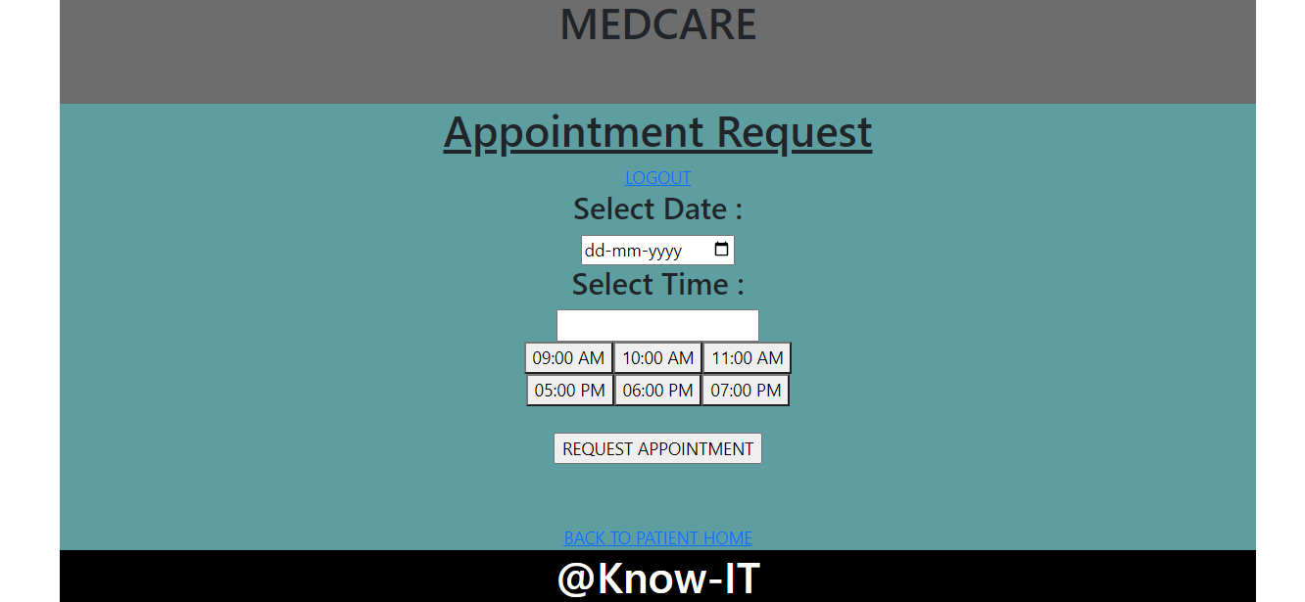

**8.3.1.1.2 Get Consultation Page**

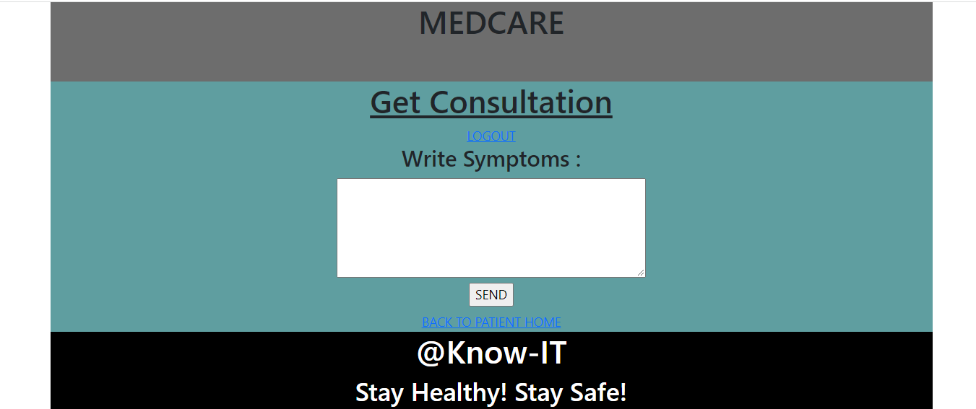

**8.4 Doctor Home**

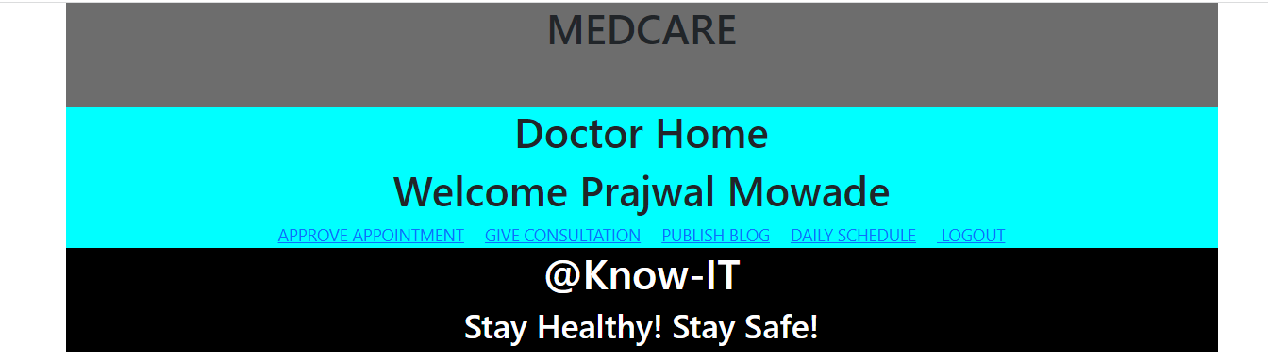

**8.4.1 Approve Appointment Page**

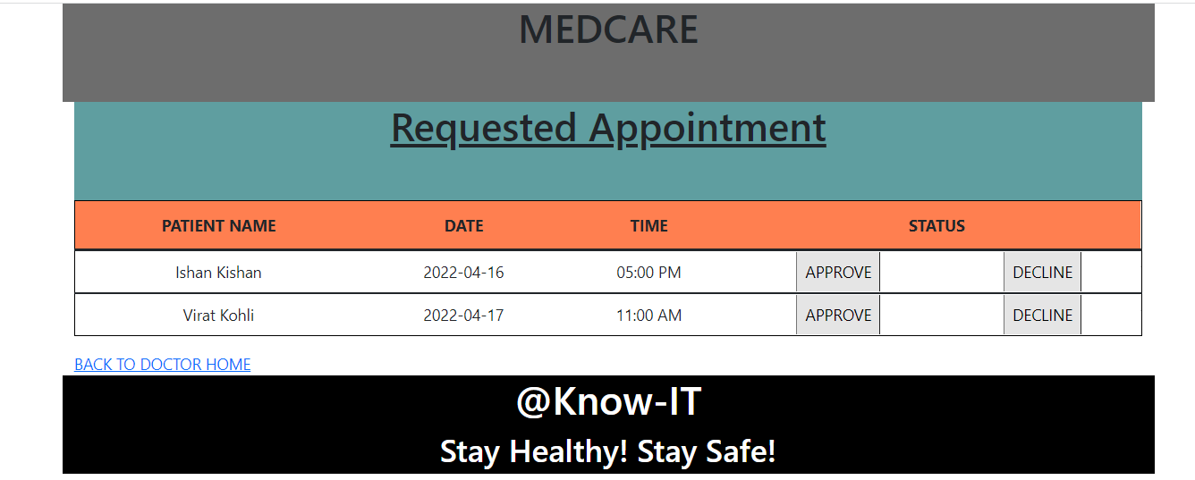

**8.4.2 Give Consultation Page**

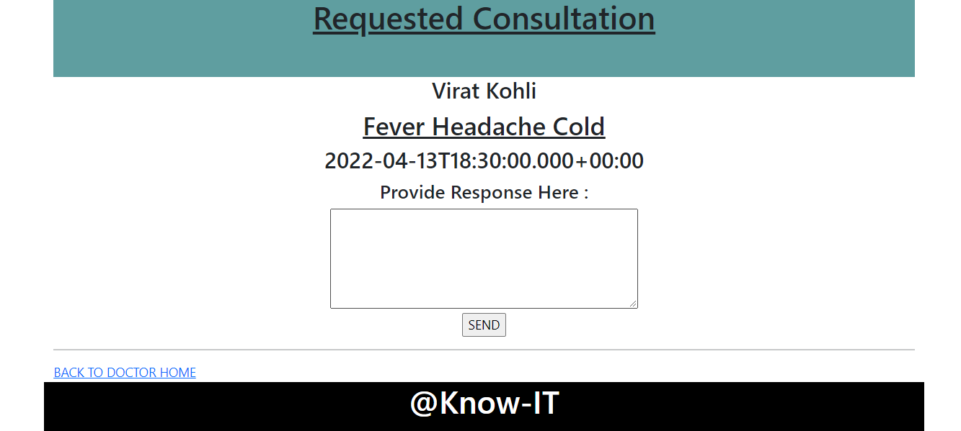

**8.4.3 Publish Blog Page**

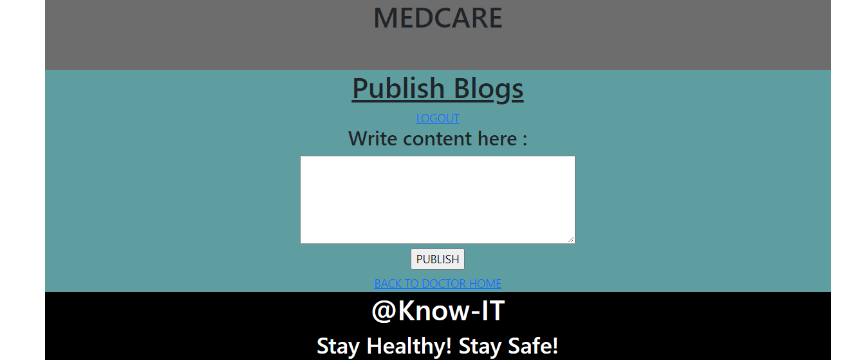

**8.4.4 Daily Schedule Page**

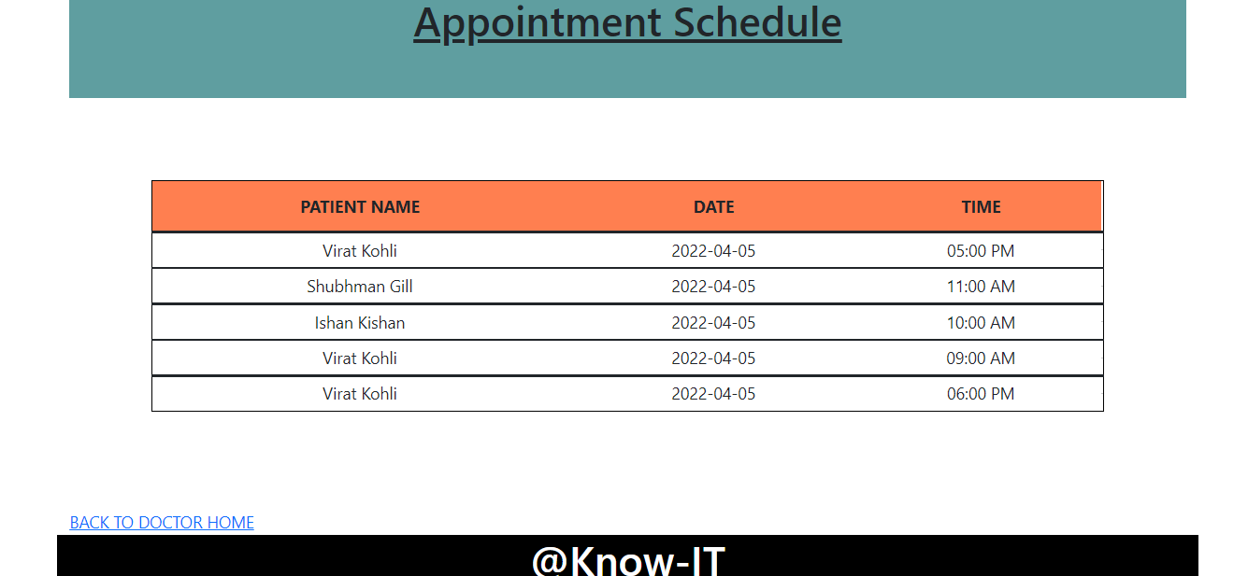

**8.5 Hospital Home**



**8.5.1 Add Doctor Page**

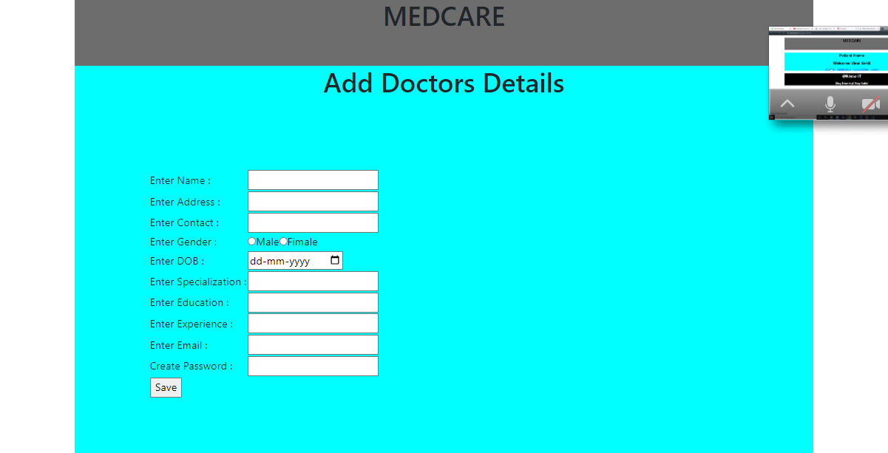

**8.5.2 Add Department Page**

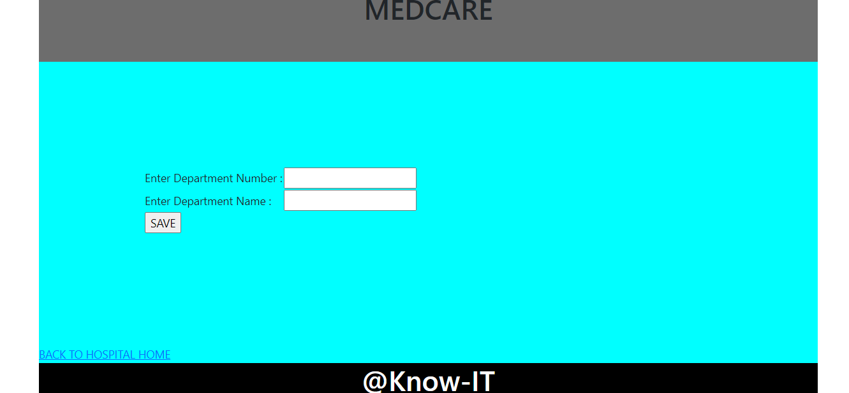

**8.6 Admin Home**



**8.6.1 Add Hospital Page**

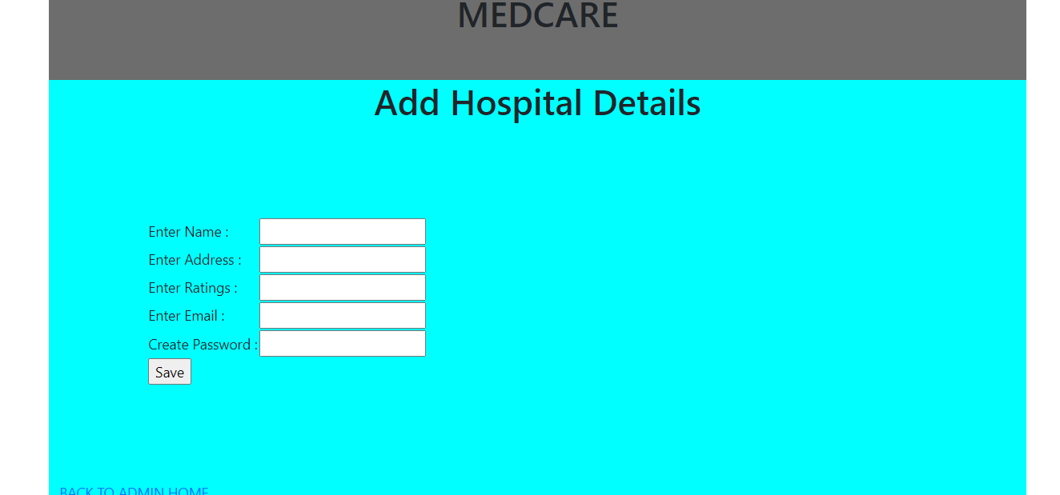

**9. CONCLUSION AND FUTURE SCOPE**

* The Web Application should use professional design, look and feel and colour scheme.
* Users will have no limitations for accessing the Web Application through Internet. The portal being an internet application.
* The system should have user friendly interface. It should be easily updated, modified and reused.
* The system should be available 24/7.
* Being a public Web Application, the application must follow general usability guidelines for menus, buttons, links and other actions provided on the screens.
* The Web Application should be designed in such a manner that user will be able to navigate easily.